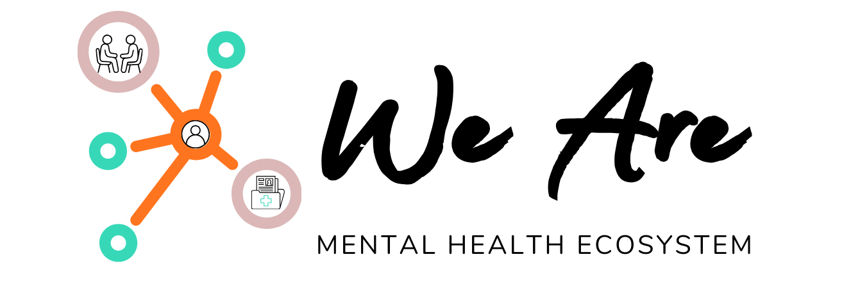

WHITE PAPER: THE 2026 CLINICAL SOVEREIGNTY STANDARD
Redefining the Managed Services Organization (MSO) for the Modern Practitioner

I. THE CRISIS OF THE "GHOST NETWORK"
As of 2026, the mental health industry has reached a breaking point. Regulatory bodies are levying unprecedented fines against major insurance payers for failing to meet Network Adequacy mandates. Simultaneously, clinicians are fleeing venture-capital-backed "therapy factories" that prioritize shareholder returns over clinical outcomes.
The result is a fractured system where patients cannot find care, and providers cannot sustain their practices. We Are was founded to solve this through a new architecture: The National Integrity Standard.

II. ARCHITECTURAL INTEGRITY: THE "WIZARDRY"
The foundation of our collective is built on a proprietary technical stack that ensures the clinician is never a "cog in the machine."
2.1 The NPI-2 Sandwich
We utilize a unique mapping of the CMS-1500 claim form to bridge the gap between independent practice and institutional bargaining power:
- Box 33 (Billing Provider): Mapped to our Master NPI-2, unlocking premium, hospital-grade reimbursement rates previously unavailable to solo practitioners.
- Box 25 (Federal Tax ID): Mapped to the Clinician’s individual EIN, ensuring the legal and financial "Direct-Flow" of funds.
2.2 Direct-Flow Adjudication
Unlike legacy platforms that hold clinician funds in custodial accounts, our 835 ERA Trigger ensures that insurance payments move directly from the payer to the clinician’s bank account. We Are only invoices its 6% administrative fee after the clinician has received payment.

III. LEGAL INTEGRITY: THE SOVEREIGN SHIELD
Our legal framework is designed for a 50-state footprint, ensuring strict compliance with Corporate Practice of Medicine (CPOM) laws.
3.1 The Clinical Firewall
We operate within a "Safe Corridor" where the MSO is contractually barred from interfering with:
- Diagnostic tests and treatment modalities.
- Referral patterns and discharge criteria.
- Patient volume or "revenue-per-hour" quotas.
3.2 The Poison Pill (Exit Protection)
To ensure we never become the "Corporate Giant" we are disrupting, our bylaws require a 100% unanimous vote from clinical members for any sale to a non-clinical entity (Private Equity or Hedge Funds).

IV. DATA INTEGRITY: THE SOVEREIGN VAULT
In an era of unethical data harvesting, we treat patient data as a sacred trust, not a product.
- FHIR-Standard Architecture: Your data is siloed in an encrypted environment that you own.
- The 48-Hour Guarantee: Because we believe in clinical autonomy, our systems are built for portability. If you leave the collective, your data moves with you in a clean, interoperable format within 48 hours. No platform lock-in, ever.

V. ECONOMIC INTEGRITY: THE 94/6 STANDARD
We believe the clinician should be the primary beneficiary of their own labor. We replace the "Black Box" percentage models of legacy platforms with a transparent utility fee.

Category | Legacy Platform | We Are Collective
Gross Payer Rate | $150.00 | $150.00
Platform Retention | 40% ($60.00) | 6% ($9.00)
Clinician Take-Home | $90.00 | $141.00

By recovering this "Integrity Gap," a full-time clinician in our ecosystem can realize an estimated $61,200 increase in annual take-home pay based on a 30-session week.

VI. THE COMMUNITY PLEDGE
Our integrity extends to the community we serve. 10% of MSO net profits are diverted to a Community Access Fund, providing grants for clinician-led research, advocacy, and hardship support for the providers who make this ecosystem possible.

VII. CONCLUSION: JOIN THE SOVEREIGNTY
The era of the "Therapy Factory" is over. The future of mental health belongs to a collective that values integrity, transparency, and clinical excellence.
We Are. Built by Clinicians. Owned by Clinicians. Protective of Clinicians.

